|  |
| --- |
| Real Time Systems using FreeRTOS – Final Project |

**From:** Ahmed Ali

# **Diagram for The System Design**

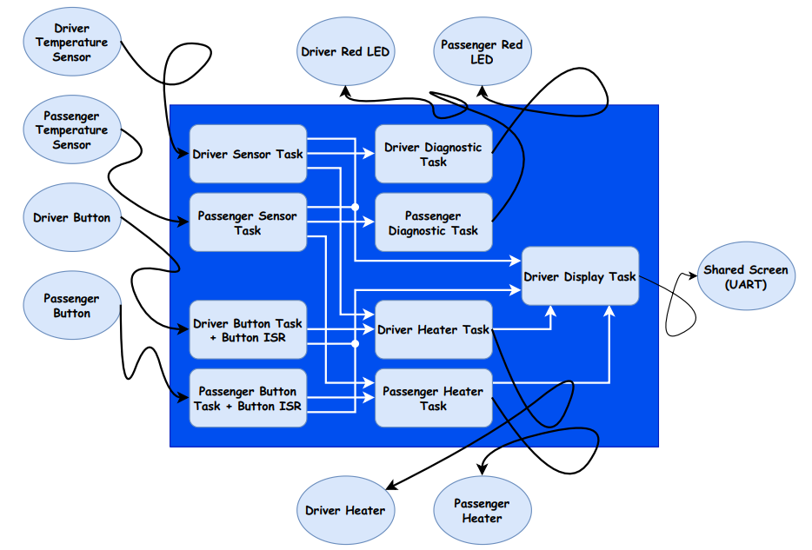

# **Task Details**

1. **Task: vDriverSensorProcessTask**

**Description:** This task processes the driver's temperature readings by retrieving data from the LM35 sensor connected to SENSOR0_CHANNEL_ID. It runs indefinitely, ensuring that the temperature is monitored at regular intervals. The task checks if the temperature is within the acceptable range (5°C to 40°C) and logs any errors if it falls outside this range.

**Type:** Periodic

**Periodicity:** 100 ms

**Set Events:** (xDriverErrorReportSemaphore) Signals that an error condition has occurred for the driver's temperature when the reading exceeds 40°C or falls below 5°C, and (xDriverDiagnosticQueue) Sends a failure log to the driver diagnostic queue when an error condition is detected.

**Wait Events:** N/A

1. **Task: vPassengerSensorsProcessTask**

**Description:** This task processes the passenger's temperature readings by retrieving data from the LM35 sensor connected to SENSOR1_CHANNEL_ID. It runs indefinitely, monitoring the temperature at regular intervals. The task checks if the temperature is within the acceptable range (5°C to 40°C) and logs any errors if it falls outside this range.

**Type:** Periodic

**Periodicity:** 100 ms

**Set Events:** (xPassengerErrorReportSemaphore) Signals that an error condition has occurred for the passenger's temperature when the reading exceeds 40°C or falls below 5°C, and (xPassengerDiagnosticQueue) Sends a failure log to the passenger diagnostic queue when an error condition is detected.

**Wait Events:** N/A

1. **Task: vDriverButtonsProcessTask**

**Description:** This task processes button inputs for the driver by waiting for specific event bits to be set in an event group, which are triggered by external interrupts (button presses). Based on the triggered event bits, the task adjusts the desired temperature settings for the driver according to the current heating level.

**Type:** Event-based

**Periodicity:** N/A

**Set Events:** N/A

**Wait Events:** (xEventGroupWaitBits) Waits indefinitely for specific button interrupt bits (mainSW1_INTERRUPT_BIT or mainSW3_INTERRUPT_BIT) to be set in the event group.

1. **Task: vPassengerButtonProcessTask**

**Description:** This task processes button inputs for the passenger by waiting for specific event bits to be set in an event group, which are triggered by external interrupts (button presses). When the event corresponding to the passenger's button is triggered, the task adjusts the desired temperature settings for the passenger based on the current heating level.

**Type:** Event-based

**Periodicity:** N/A

**Set Events:** N/A

**Wait Events:** (xEventGroupWaitBits) Waits indefinitely for specific button interrupt bit (mainSW2_INTERRUPT_BIT) to be set in the event group.

1. **Task: vDriverHeaterProcessTask**

**Description:** This task periodically controls the driver's heating system based on the temperature difference between the desired and current temperatures. The heater's intensity is simulated using LEDs to reflect different heating levels:

* Low intensity: Green LED
* Medium intensity: Blue LED
* High intensity: Both Green and Blue LEDs (Cyan).

If the current temperature exceeds the desired temperature, the heater is turned off. The task is designed to minimize unnecessary updates to the LEDs, only changing their states when necessary.

**Type:** Periodic

**Periodicity:** 250ms

**Set Events:** N/A

**Wait Events:** N/A

1. **Task: vPassengerHeatersProcessTask**

**Description:** This task periodically controls the passenger’s heating system based on the temperature difference between the desired and current temperatures. The heater's intensity is simulated using LEDs to reflect different heating levels:

* Low intensity: Green LED
* Medium intensity: Blue LED
* High intensity: Both Green and Blue LEDs (Cyan).

If the current temperature exceeds the desired temperature, the heater is turned off. The task is designed to minimize unnecessary updates to the LEDs, only changing their states when necessary.

**Type:** Periodic

**Periodicity:** 250ms

**Set Events:** N/A

**Wait Events:** N/A

1. **Task: vDriverDiagnosticTask**

**Description:** This task is responsible for handling error reporting related to the driver's temperature sensors. It monitors for error conditions and takes appropriate actions when faults are detected, ensuring the safety of the heating system.

**Type:** Event-based

**Periodicity:** N/A

**Set Events:** N/A

**Wait Events:** (xDriverErrorReportSemaphore) Waits indefinitely for specific semaphore is signaled by another task when a fault is detected in the driver's temperature sensors, and (xDriverDiagnosticQueue) task attempts to retrieve diagnostic data.

1. **Task: vDriverDiagnosticTask**

**Description:** This task is responsible for handling error reporting related to the passenger’s temperature sensors. It monitors for error conditions and takes appropriate actions when faults are detected, ensuring the safety of the heating system.

**Type:** Event-based

**Periodicity:** N/A

**Set Events:** N/A

**Wait Events:** (xPassengerErrorReportSemaphore) Waits indefinitely for specific semaphore is signaled by another task when a fault is detected in the driver's temperature sensors, and (xPassengerDiagnosticQueue) task attempts to retrieve diagnostic data.

1. **Task: vDisplayScreenTask**

**Description:** This task periodically checks for changes in system status and displays the current and desired temperatures for both the driver and passenger, along with the current state of the heaters.

**Type:** Periodic

**Periodicity:** 500ms

**Set Events:** N/A

**Wait Events:** N/A

# **Shared resources**

|  |  |  |
| --- | --- | --- |
| Shared Resource | Shared by Tasks | Exclusive Access Method |
| ucDriverHeaterState | vDriverHeatersProcessTask, vDriverDiagnosticTask, vDisplayScreenTask | Mutex (xDriverHeaterStateMutex) |
| ucPassengerHeaterState | vPassengerHeatersProcessTask, vPassengerDiagnosticTask, vDisplayScreenTask | Mutex (xPassengerHeaterStateMutex) |
| ucDriverHeatingLevel | vDriverHeatersProcessTask, vDisplayScreenTask | Mutex (xDriverHeatingLevelMutex) |
| ucPassengerHeatingLevel | vPassengerHeatersProcessTask, vDisplayScreenTask | Mutex (xPassengerHeatingLevelMutex |
| ucDriverTemperatureValue | vDriverSensorTask, vDriverHeatersProcessTask, vDriverDiagnosticTask, vDisplayScreenTask | Mutex (xDriverTempValueMutex) |
| ucPassengerTemperatureValue | vPassengerSensorTask, vPassengerHeatersProcessTask, vPassengerDiagnosticTask, vDisplayScreenTask | Mutex (xPassengerTempValueMutex) |
| ucDriverDesiredTemperature | vDriverHeatersProcessTask, vDriverSensorTask | Mutex (xDriverDesiredTempMutex) |
| ucPassengerDesiredTemperature | vPassengerHeatersProcessTask, vPassengerSensorTask | Mutex (xPassengerDesiredTempMutex) |
| UART Interface (UART0) | vDisplayScreenTask, vRunTimeMeasurementsTask | Mutex (xDisplayScreenMutex) |

# **Screenshots**

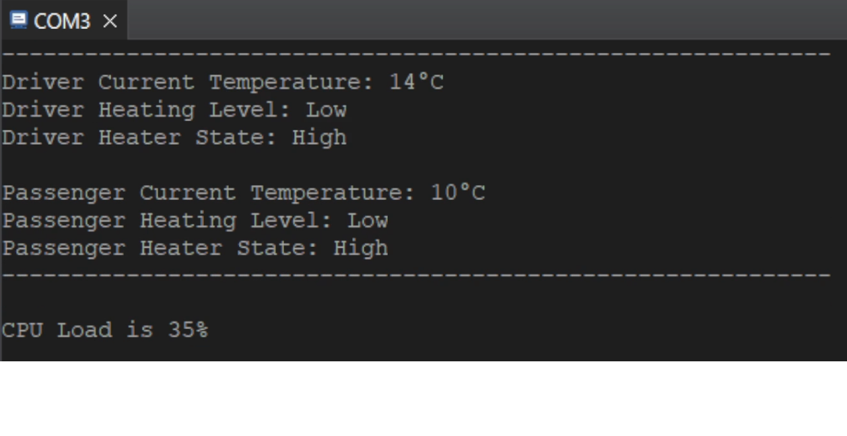

# **Run Time Measurement**

|  |  |  |
| --- | --- | --- |
| Task Name | Execution Time (ms) | Percentage (%) |
| Driver Sensor Process Task | 1.32ms | 0.132% |
| Passenger Sensors Process Task | 1.76ms | 0.176% |
| Driver Buttons Process Task | 0.1ms | 0.01% |
| Passenger Button Process Task | 0.1ms | 0.01% |
| Driver Heater Process Task | 0.84ms | 0.084% |
| Passenger Heater Process Task | 0.64ms | 0.064% |
| Driver Diagnostic Task | 0.1ms | 0.01% |
| Passenger Diagnostic Task | 0.2ms | 0.02% |
| Display Screen Task | 357.2ms | 35.72% |

$CPU LOAD=\frac{1.32+1.76+0.1+0.1+0.84+0.64+0.1+0.2+375.2}{1000}$* 100 = 36.226%

# **Simso Simulation Results**

